SET 3 — Employee Performance Evaluation
According to your experiment sheet, Set 3 uses Employee Performance data and asks for a line chart, department bar chart, scatter plot, and Tableau dashboard.
Dataset
Employee ID | Department | Years of Service | Performance Score
1 | Sales | 5 | 85
2 | HR | 3 | 92
3 | Marketing | 7 | 78
4 | Sales | 4 | 90
5 | HR | 2 | 76

AIM
To analyze employee performance data using R programming and visualize employee performance trends, department distribution, and the relationship between years of service and performance scores.
ALGORITHM
- Start RStudio.
- Create the employee performance dataset.
- Store Employee ID, Department, Years of Service, and Performance Score.
- Create a line chart to visualize employee performance.
- Create a bar chart to show employees across different departments.
- Create a scatter plot between years of service and performance score.
- Calculate the correlation between years of service and performance score.
- Add suitable titles and axis labels.
- Display the graphs and results.
- Stop.
R CODE
employee <- data.frame(
ID=c(1,2,3,4,5),
Department=c("Sales","HR","Marketing","Sales","HR"),
Years=c(5,3,7,4,2),
Performance=c(85,92,78,90,76)
)

# 1. Line Chart
plot(employee$Years,employee$Performance,
type="o",
main="Employee Performance Trend",
xlab="Years of Service",
ylab="Performance Score")

# 2. Bar Chart
dept <- table(employee$Department)

barplot(dept,
main="Employees by Department",
xlab="Department",
ylab="Number of Employees")

# 3. Scatter Plot
plot(employee$Years,employee$Performance,
main="Years of Service vs Performance",
xlab="Years of Service",
ylab="Performance Score",
pch=19)

abline(lm(Performance~Years,data=employee))

# Correlation
cor(employee$Years,employee$Performance)

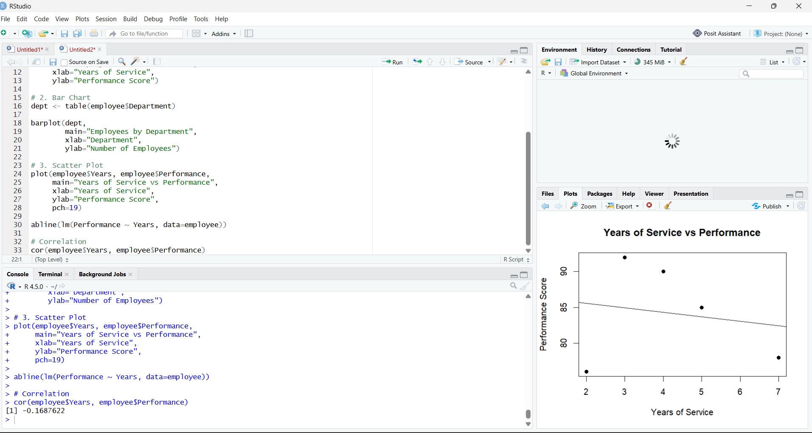

RESULT
Thus, the Employee Performance data was successfully analyzed using R programming. The line chart, bar chart, and scatter plot were successfully created to visualize employee performance, department distribution, and the relationship between years of service and performance score.

